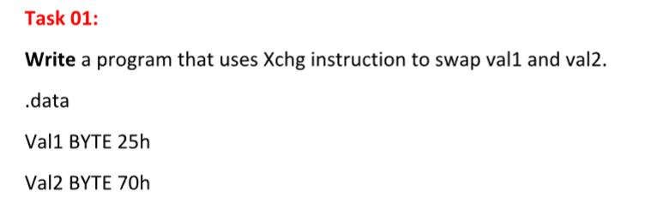

Solution:
INCLUDE Irvine32.inc

.data
Val1 BYTE 25h
Val2 BYTE 70h

.code
main PROC

mov al, Val1
xchg al, Val2
mov Val1, al

movzx eax, Val1
movzx ebx, Val2

call DumpRegs

exit

main ENDP
END main

Output:
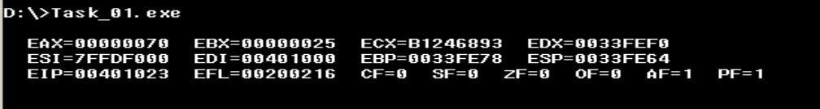
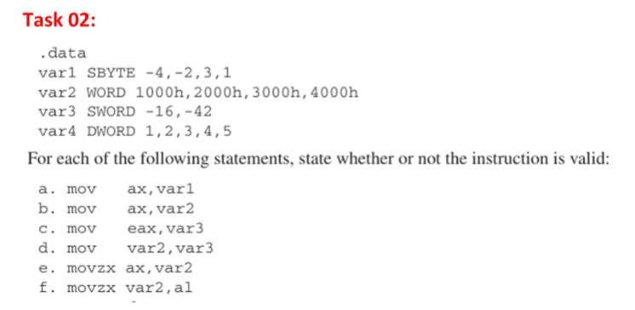
Solution:
- mov ax, var1
Invalid
AX = 16-bit,
- mov var2, var3
Invalid
Memory to memory not allowed

- movzx ax, var2
Invalid
movzx works from smaller → larger, but here both are 16-bit

- movzx var2, al
Invalid
Destination must be a register, not memory

var1 = 8-bit (size mismatch)

- mov ax, var2
Valid
Both are 16-bit

- mov eax, var3
Invalid
EAX = 32-bit,
var3 = 16-bit

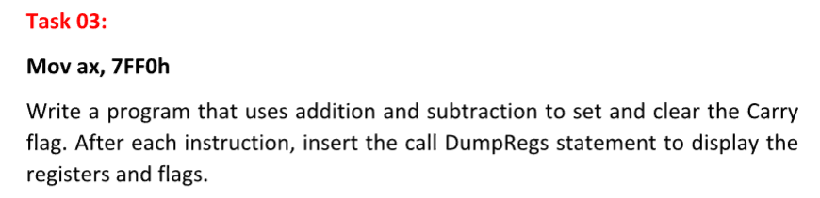
Solution:
INCLUDE Irvine32.inc

.code
main PROC

mov ax, 7FF0h
call DumpRegs

add ax, 9000h
call DumpRegs

sub ax, 1000h
call DumpRegs

exit

main ENDP
END main

Output:
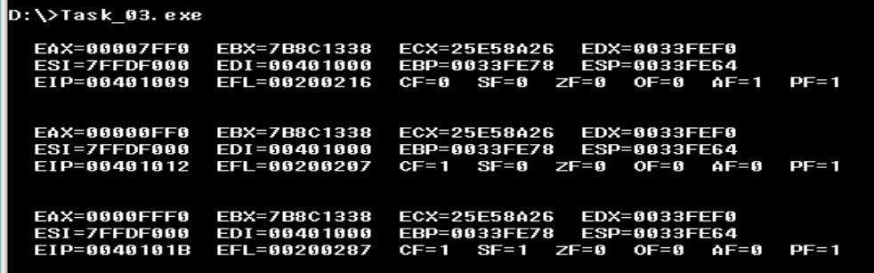

Task 03 (B)
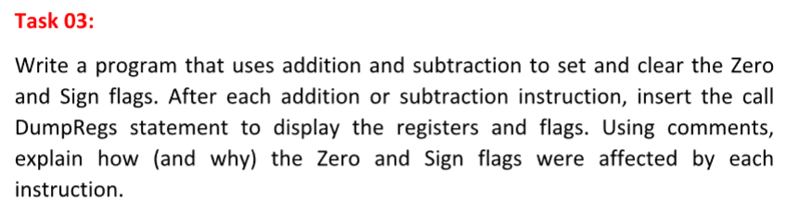
Solution:
INCLUDE Irvine32.inc

.code
main PROC

;Addition (positive result)
; EAX = 3 + 1 = 4
; ZF = 0 (result is not zero)
; SF = 0 (result is positive)
; -------------------------------
mov eax, 3
add eax, 1
call DumpRegs ; Display registers and flags

; -------------------------------
; CASE 2: Subtraction resulting in ZERO
; EAX = 4 - 4 = 0
; ZF = 1 (result is zero → flag set)
; SF = 0 (zero is not negative)
; -------------------------------
sub eax, 4
call DumpRegs ; ZF becomes 1 here

; -------------------------------
; CASE 3: Subtraction resulting in NEGATIVE value
; EAX = 0 - 5 = -5
; ZF = 0 (result is not zero)
; SF = 1 (negative result → sign bit set)
; -------------------------------
sub eax, 5
call DumpRegs ; SF becomes 1 here

; -------------------------------
; CASE 4: Addition producing negative result (via overflowed signed view)
; EAX = -5 + (-3) = -8
; ZF = 0 (not zero)
; SF = 1 (still negative)
; -------------------------------
sub eax, 3
call DumpRegs

exit
main ENDP

END main

Output:
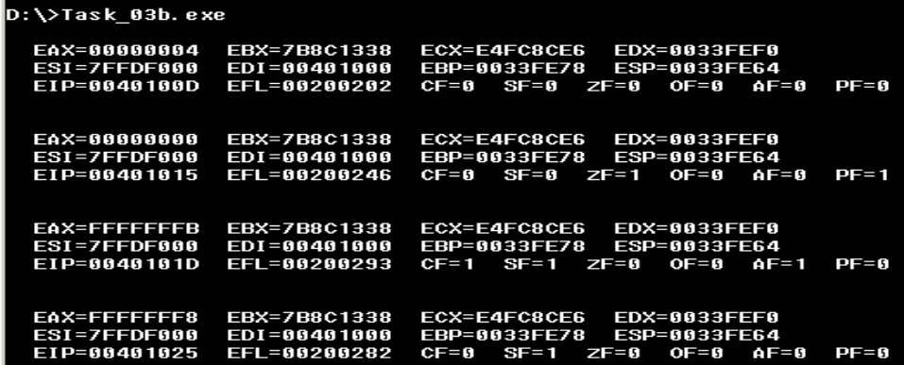

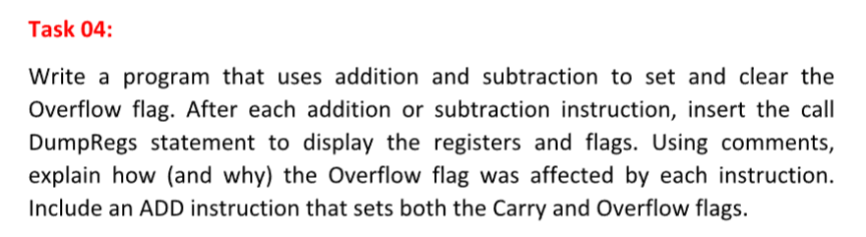
Solution:
INCLUDE Irvine32.inc

.code
main PROC

; -------------------------------
; Example 1: Set Overflow (OF = 1)
; -------------------------------
mov al, 7Fh ; 7Fh = +127 (max positive for signed 8-bit)
add al, 1 ; 127 + 1 = -128 (overflow in signed)
; OF = 1 because result exceeds signed range
call DumpRegs

; -------------------------------
; Example 2: Clear Overflow (OF = 0)
; -------------------------------
mov al, 10h ; small positive number
add al, 10h ; normal addition (no overflow)
; OF = 0
call DumpRegs

; -------------------------------
; Example 3: Subtraction causing Overflow
; -------------------------------
mov al, 80h ; 80h = -128 (min signed)
sub al, 1 ; -128 - 1 = +127 (overflow)
; OF = 1 (out of signed range)
call DumpRegs

; -------------------------------
; Example 4: ADD sets both CF and OF
; -------------------------------
mov al, 7Fh ; +127
add al, 81h ; +127 + (-127) but unsigned overflow occurs
; Result causes:
; CF = 1 (unsigned overflow)
; OF = 1 (signed overflow)
call DumpRegs

exit

main ENDP
END main

Output:
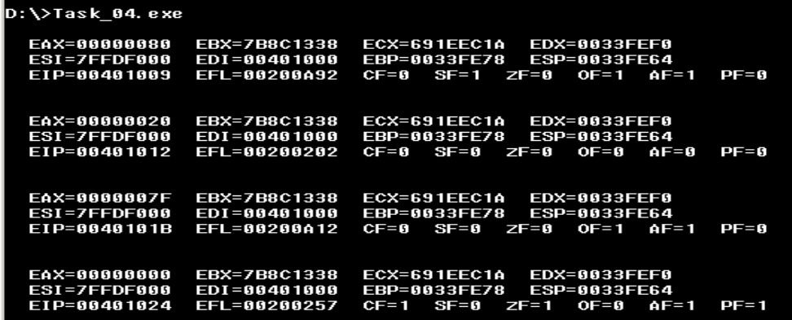

Task No 05
INCLUDE Irvine32.inc

.data
Uarray WORD 1000h,2000h,3000h,4000h
Sarray SWORD -1,-2,-3,-4

.code
main PROC

movzx eax, Uarray
movzx ebx, Uarray+2
movzx ecx, Uarray+4
movzx edx, Uarray+6

call DumpRegs

movsx eax, Sarray
movsx ebx, Sarray+2
movsx ecx, Sarray+4
movsx edx, Sarray+6

call DumpRegs

exit
main ENDP

END main

Output:
